WEEK NO. | PROBLEMS WITH DESCRIPTION. |  | SIGNATURE OF THE TEACHER WITH DATE
1 | 1 | In your own words, explain Web Engineering.
 | 2 | Explore and list core technologies used in Web Engineering, including HTML, CSS,  JavaScript, and PHP, and explain the role of each.
 | 3 | Identify front-end and back-end technologies used in web development and give examples of each.
 | 4 | Explore popular web frameworks or platforms and write short notes on any two.
 | 5 | Write a short note on the usage of web technologies in education, business or social platforms
2 | 1 | In your own words, explain what Data Science is and why it is important in today’s world.
 | 2 | Identify and describe any five real-world datasets.
 | 3 | List major tools used in Data Science (programming languages, libraries, platforms) and state  their purpose.
 | 4 | Explore and write short notes on any three Data Science frameworks.
 | 5 | Identify different roles in Data Science (e.g., Data Analyst, Data Scientist, ML Engineer) and  their responsibilities.
 | 6 | Write a short note on the usage of Data Science being in your own domain of interest.
3 | 1 | Write a Python program to read a number and check whether it is even or odd.
 | 2 | Write a Python program to find the largest of three numbers using conditional statements.
 | 3 | Write a Python program to generate the first n Fibonacci numbers using a loop.
 | 4 | Write a Python program to count the number of vowels in a given string.
 | Problems Based on HTML
 | 5 | Create a HTML page with the following:  - Webpage Title “My first web page”.  - Add BGCOLOR, TEXT attributes to the body.  - Show the use of different heading tags.  - Add two paragraphs to your webpage.  Show these text with following formatting along with line break:  - Italics – “This text is italics”  - Bold – “This text is bold”  - Underline – “This text is underline”.
 | 6 | Create a web page to show this output:  - List of fruits:  - Apple  - Banana  - Guava  - List of Vegetables:  - Carrot  - Cabbage  - Spinach
 | 7 | Create the following table in HTML with Dummy Data:  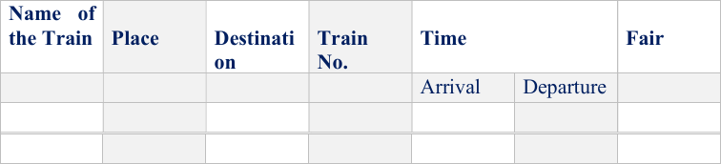

4 | 1 | Create a list of numbers and find the sum and average of the list.
 | 2 | Write a function to check whether a given string is a palindrome.
 | 3 | Create a dictionary of student names and marks. Display students scoring above 75.
 | 4 | Write a program to sort a list in ascending and descending order.
 | Problems based on HTML
 | 5 | Write HTML code to generate the following output:  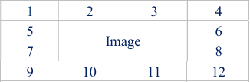
 | 6 | Write an HTML code to develop a Web page having two frames that divide the Web page into two equal rows and then divide the second row into two equal columns, then fill each frame  with a different background color.
 | 7 | Design an HTML Page having 3 images placed in the following format. (Hint: Figure 1)  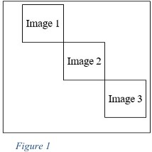
5 | 1 | Create a NumPy array and display its shape, size, and data type.
 | 2 | Perform at least five basic arithmetic operations on NumPy arrays (addition of two arrays,  subtraction, etc.)
 | 3 | Create a NumPy array from having numbers between 1 to 100 and print only the prime  numbers in them.
 | 4 | Take a NumPy array and demonstrate indexing and slicing on it.
 | Problems based on HTML
 | 5 | Write the code to develop a Web page, as shown below, using frames:  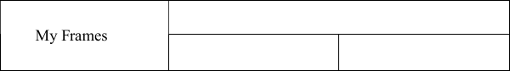
 | 6 | Design a page with a text box called ‘name’ and a button with label ‘Enter.’ When you click on the button, another page should open, with the message “Welcome ”, where name should be equal to the name entered in the first page. Set default value of ‘name’ text box to Victoria. Add another button called Reset on click of this button name ‘text box’ should be set to 100  default values.
 | 7 | Design a form in HTML using all input types.
6 | 1 | Create a NumPy array and compute mean, median, and standard deviation of its data.
 | 2 | Perform matrix addition and multiplication using NumPy.
 | 3 | Generate a random array and find its maximum and minimum values.
 | 4 | Reshape a one-dimensional array into a matrix of different sizes
 | Problems based on HTML and JavaScript
 | 5 | Design a Web Page, which is like ‘compose’ page of e-mail  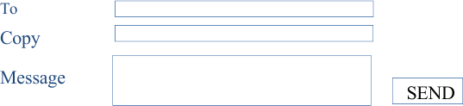
 | 6 | Design a series of three HTML Pages for ABC.COM, each called from the previous one. Accept Name on the first page. When the user clicks on the enter button, second page should open. The second page should not display the name but a ‘Welcome screen with some  information about ABC.COM. When the user will click on the ‘next’ button it should display the name accepted in page 1 on page 3. (Hint: you may use hidden fields)
 | 7 | Write the segment of Script that would ask the user if he wants a greeting message and if he does, display a Gif file called Welcome.gif and display “Welcome to Department of Computer Science!” in the document window following the Gif.

7 | 1 | Create a Pandas Series from a list and a DataFrame from a dictionary.
 | 2 | Load a CSV file and display the first five rows and display head, tail, and info of a dataset.
 | 3 | Take a DataFrame and do the following:  - What is the average value of the second column?  - What is the average value of the first 5 rows of the third and fourth columns?  - Compute the row wise sum of all possible values in an array.  - Find the maximum of average value in each row.
 | Problems Based on HTML and JavaScript
 | 4 | Write a program to display a multiplication table.
 | 5 | Create a Web page using two image files, which switch between one another as the mouse  pointer moves over the image. Use the On Mouse over and On Mouse out event handler.
 | 6 | Use the date function gets Date & set Date to prompt the user for an integer between 1 – 31 &  return day of the week it represents.
8 | 1 | Read a dataset and identify the information about the missing values in a dataset.
 | 2 | Handle missing values using mean/median/other approaches.
 | 3 | Rename columns of the datasets and change their data types.
 | 4 | Filter rows and columns based on specific conditions (such as remove rows with missing  values, if value is less than 50 etc.).
 | Problems based on HTML and JavaScript
 | 5 | Display time and print message accordingly e.g., ‘Good Morning’ in Morning etc.
 | 6 | Using JavaScript create a digital clock.
 | 7 | Design a form as shown below:  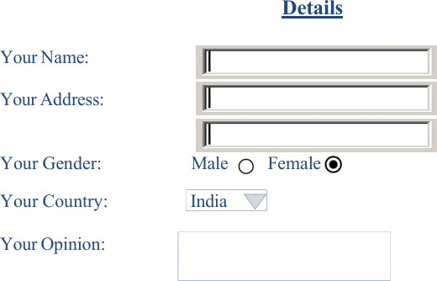
9 | 1 | Read a dataset and compute summary statistics of numerical columns.
 | 2 | Find correlations between numerical feature and remove highly correlated columns.
 | 3 | Draw boxplots, identify outliers and remove them.
 | 4 | Perform all EDA operations on a dataset.
 | Problems based on HTML and CSS
 | 5 | Create a website that has a questionnaire (any), on submitting, it displays the inputted data on  the other page. You are supposed to use CSS (wherever necessary).
 | 6 | Create a website that divides the Web page into two unequal frames. In Frame One, there are two links to two different forms. The forms are validated on submitting and the result is  shown at the bottom of the same page. Use CSS for formatting.
10 | 1 | Read a dataset and create different line and bar plots using Matplotlib.
 | 2 | Use the same dataset and plot histograms and boxplots using Seaborn.
 | 3 | Create scatter plots for feature relationships and generate a correlation heatmap
 | Problems based on HTML and JavaScript
 | 4 | Develop a Web page with the following enhancements: • A rollover effect, where an image changes if the user places the mouse over it.  - An animation that occurs in response to the user clicking on an image.  - A pull-down menu with each option linking to a specific page.
 | 5 | Display the calendar using JAVA SCRIPT code by getting the year from the user.

11 | 1 | Read a dataset and split a dataset into training and testing sets.
 | 2 | Implement a simple linear regression model.
 | 3 | Evaluate regression performance using MAE and RMSE. and visualize actual vs predicted  values.
 | 4 | Change the regression model and compare the performance with the previous model.
 | Problems Based on HTML, Java Script and XML:
 | 5 | Create a HTML registration form and to validate the form using java script code.
 | 6 | Create a HTML file to open new window from the current window using JavaScript.
 | 7 | Create an HTML page with 2 combo box populated with month & year, to display the  calendar for the selected month & year from combo box using JavaScript.
12 | 1 | Read a dataset and implement a basic classification model.
 | 2 | Generate and interpret a confusion matrix. Calculate accuracy, precision, recall, and F1 score  and visualize classification results.
 | 3 | Use various classification models and compare them on the same datasets
 | Problems Based on HTML and XML:
 | 4 | Create a CD catalog using XML file.
 | 5 | Create external style sheet and using the style sheet in XML file.
 | 6 | Create an XSL style sheet to display the data in the xml using HTML table.
13 | 1 | Read a dataset and apply feature scaling techniques.
 | 2 | Demonstrate overfitting using scores and adjust the model, if required.
 | 3 | Apply basic hyperparameter tuning and compare it with default setting.
 | Problems Based on HTML, Java Script, XML and PHP:
 | 4 | Create a PHP program to demonstrate the different predefined function in array, Math, Data &  Regular Expression.
 | 5 | Create a PHP file that contains one textbox for Salary and one Submit button. If user provides salary and submits the button, then name of such employees should be displayed, who are having salary less than Salary value supplied by the user. Write prepared statements for  database query. (Note: Schema of Employee table is Employee (EmployeeID, Name, Salary, DepartmentID)).
14 | 1 | Perform EDA on an application-based dataset.
 | 2 | Build an end-to-end ML pipeline.
 | Problems Based on HTML and PHP:
 | 3 | Design a page that contains four textboxes for Name, Email ID, Age and Address and one Submit button. Once user supplied these values a server-side validation should be performed  and data should be inserted into the table Employee (Name, Email ID, Age, Address)).

